|  |  |
| --- | --- |
|  | SALES REPORT 2017 |
|  |  |
| 7/12/2017 | By: Ratnam Dubey |
|  |  |

#### **Problem Statements HIGHLIGHTS**

Sales are down in the US for the first four months of 2017 compared to the first four months of 2016. Why?

1. Are there any demographic factors that could account for the decline in sales?
2. Have there been any changes to the Key Performance Indicators that would account for this drop? (Ex: Renewal Rates, Average Selling Prices, etc.)
3. Are we experiencing a lag in the timing of subscription renewals?
4. Are there other factors that could be influencing the year-over-year decline?
5. Based on these results, project total renewed dollars for all subscriptions expiring in 2017.

What recommendations do you have to improve subscription renewals for the rest of the year?

1. From the given set of data, what are the key factors influencing renewals?
2. What would be the expected renewal rate for 2017?
3. Is it possible to flag the schools that are at high risk of not renewing?
4. Are there levers that the sales and customer service teams can pull, to positively influence renewal rates?

SALES REPORT 2017

By: Ratnam Dubey

About

Renaissance Learning, Inc. (Renaissance) is a software and [learning analytics](https://en.wikipedia.org/wiki/Learning_analytics) company that makes cloud-based, K–12 educational software. Renaissance employs about 1200 employees in nine U.S. cities and subsidiaries in Canada, the United Kingdom, Korea, and Australia. Renaissance’s products are used in U.S. schools and more than 60 countries around the world

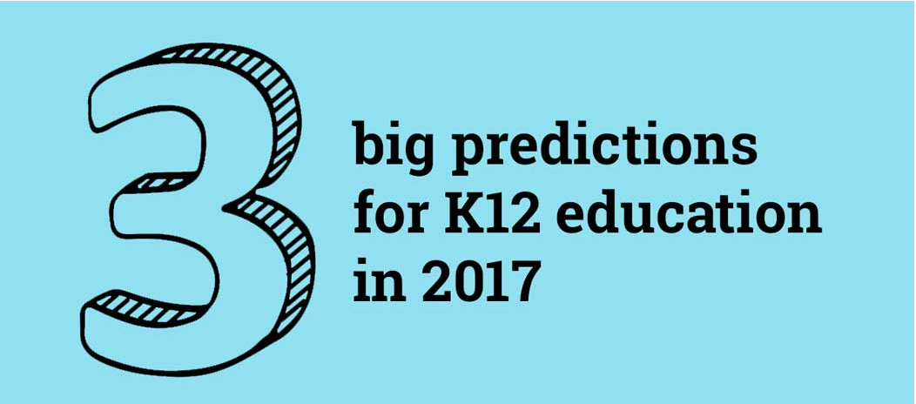

1. Personalized learning and more flexibility for demonstrating mastery

2. Technology will continue to have an increased impact on education

3. More vivid, visual, dynamic student data

#### **Financial ANALYSIS Summary:**

Sales are directly related to cost so any time an event takes place or is about to take place that causes a spike in sales. Consolidated net sales, fell, below the previous comparable year period due to the strong factors that are affecting the sales like: -

1. Changes in Average price. i.e. Student to amount ratio.
2. Changes in Schools Renew pattern. i.e. Time lag in Renewing the Subscription.
3. Changes in Demographic factors.

Apart from the Changes there are other factors in data that can help to understand the Marketing strategies based on predictive models that can predict the probability of Subscribing Schools and time duration in which there is probability of getting subscribed.

This data on a predictive model such as a Classification model with target on the Subscription renewed or not renewed will create a prediction on various factors, like Demographic Information and other factors which are generated from the data like Average Selling price.

#### **SALES Drop 2017 Analysis assumptions**

Following Assumptions has been taken for Analyzing the data based on Data Understanding and Data Structure. Financial assumptions and projections are critical components of all business plans.

1. Sales drop is considered for the Schools having status as “Not Renewed” in Subscription Status.
2. Actual Sales is Considered as Subscription status as “Renewed” in 2017 Sales Data Sheet.
3. Demographic Changes for missing values is considered as minimal.
4. Demographic file contains all the School ID in 2016 and 2017.
5. Subscription Date before the renewal date has been considered as pre-renewal of the Subscription.
6. In 2016 Data set Subscription Status as “Not Renewed” will not Renew.
7. Data Set 2015-2016 Considered as 2016 Sales whereas Data set 2017 considered as 2017 Sales.

#### **SALES Drop 2017 Analysis**

Financial loss has been indicated in the Sales, due to less subscription amongst the Customers. Sales has drop significantly over a year period.

Sales has dropped approx. 70% over a year for the Renewal Data compared with 2016 Sales and 2017 Sales.

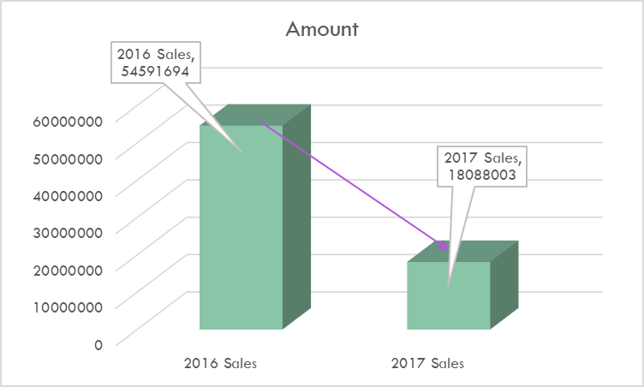

Various Factors are there for the drop of Sales in year 2017, In Further analysis it has been found that these key factors have direct impact on the sales revenue.

#### **Overview of Demographic Changes.**

The ultimate objective of all the marketing efforts is to reach the end consumers with the product and service of their need with a reasonable price which they could easily afford. The purpose of this research is to analyze the impact of demographic factors on consumer choice along with the increasing sales in areas having significant drop in sales. Customer is the focus of all the marketing activities. Knowledge of his activities and behavior is one of the most important aspects of the marketing which can further led to Increase in sales.

Analyzing the Locations that are Affecting the Sales.

As to Analyze the pattern over the Sales drop we need to Understand the key factors and the dictionary as to understand the graphs

Graphs Understanding: -

**Metro Code**

R: Rural Areas U: Urban

S: Sub-Urban T: Town

**Subscription Status**

Not Renewed: Subscription Not Get Renewed

Renewed: Subscription Get Renewed

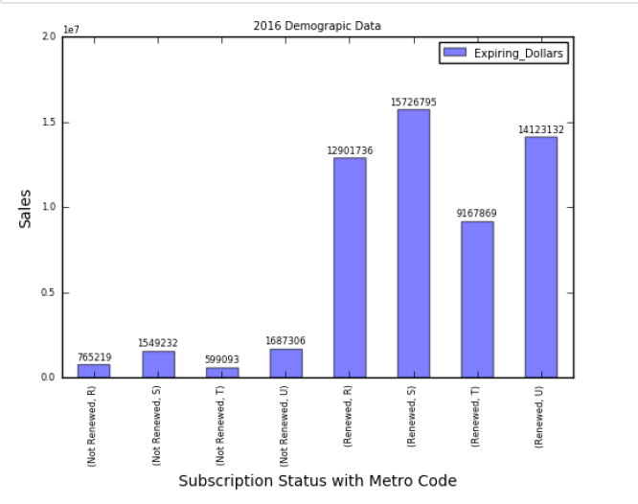

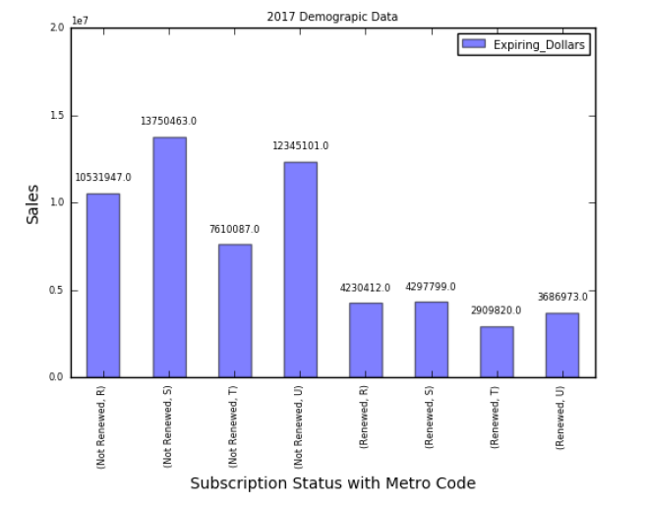

All the Locations Sales has been dropped Significantly. Whereas non-renew data has been increased in 2017 compared to 2016 data.

Analyzing the drop there is one question that comes to mind, that, “what is the actual reasons of Sale drop?”

#### **Average Selling price comparison 2016-2017**

Average Selling price of the product is the Total sales generated from the school to the Number of the Students using the Application.

Average Selling Price = Sales from a School / Number of Students

In 2015 the Average Sales Prices are quite low. Average Sales price in 2015 was 6$, which got increased in 2016 as 7$, further prices again got hiked in 2017 as 8$ which has serious impacts on the sales.

6.0 Represents – 6$ which is the Average Sales price of 2015

7.0 Represents – 7$ which is the Average Sales price of 2016

8.0 Represents – 8$ which is the Average Sales price of 2017

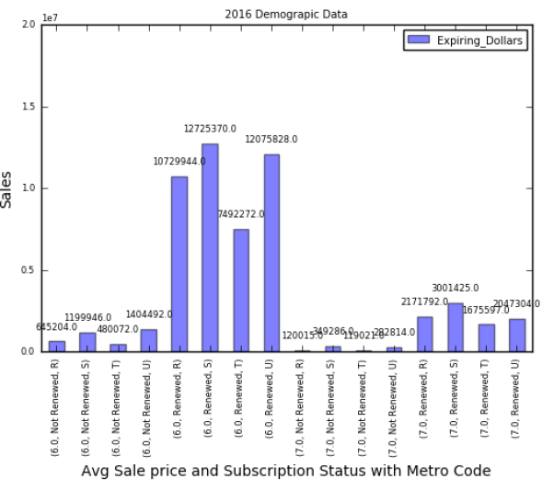

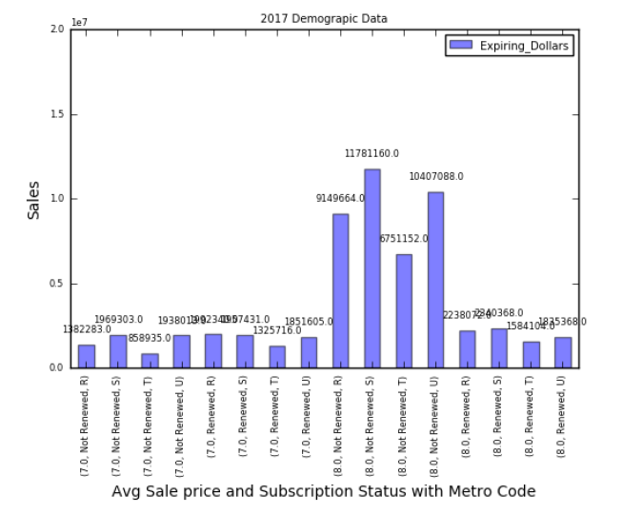

*Renewed Subscription Sales*

Blue Indicates 2016 Sales Data, whereas Red Indicates 2017 Sales Change.

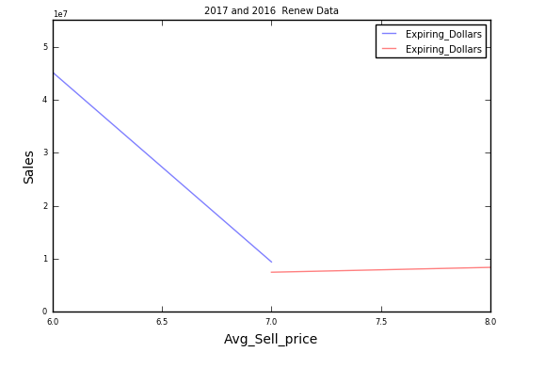

*NON-Renewed Sales Drop (Sale Loss)*

Blue Indicates 2016 Sales Data, whereas Red Indicates 2017 Sales Change.

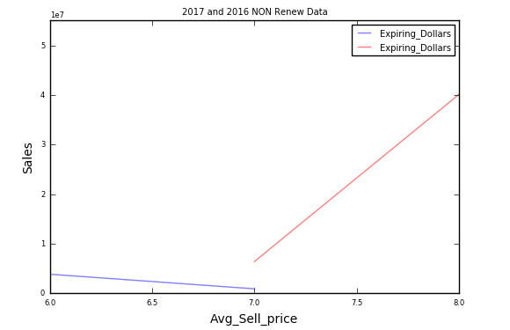

As the Sales prices hiked from $6 to $7 or 7$ to 8$ there is drop in Sales after the prices got hiked. Not Renewed Data in 2016 compared to 2015 data has been dropped, whereas Sales drop (Not Renewed Data) in 2017 after hike from 7$ to 8$ has been increased. All Demographic locations has seen significant drop in sales for 2017 Data except in rural areas.

S: Space Sales has been dropped 22% approx.

T: Town Sales has been dropped around 6%.

U: Urban areas Sales been dropped around 11%.

#### **Subscription Renewal Time lag 2016-2017**

Subscription renewal of the product is the time taken for the renewal of the product, Products can be renewed before the expiration known as pre-extension or the products can be renewed after the expiration of the renewal known as post-extension.

As there are various days in which renewals can happen extending from 0 to more than 365 days, analyzing such huge number of the days are difficult and hard to find the pattern in the renewals, to understand better the pattern, grouping of Days been introduced due to which analysis will be easy as to find the pattern.

Graphs Understanding: -

**Time lag Code**

Renewed Data: Number Represents Days, Numbers with “- “represents pre-renewal of Subscription

More than 180 taken to renew the Subscription: Group 10

Less than or equal 180 and more than 150 to renew the Subscription: Group 9

Less than or equal 150 and more than 120 to renew the Subscription: Group 8

Less than or equal 120 and more than 90 to renew the Subscription: Group 7

Less than or equal 90 and more than 30 to renew the Subscription: Group 6

Less than or equal 30 and more than 0 to renew the Subscription: Group 5

Less than or equal -1 and more than -30 to renew the Subscription: Group 4

Less than or equal -30 and more than -90 to renew the Subscription: Group 3

Less than or equal -90 and more than -150 to renew the Subscription: Group 2

Less than or equal -151 and more than -400 to renew the Subscription: Group 1

NON-Renewed Data

Non-Renewed Data is represented in: Group 11

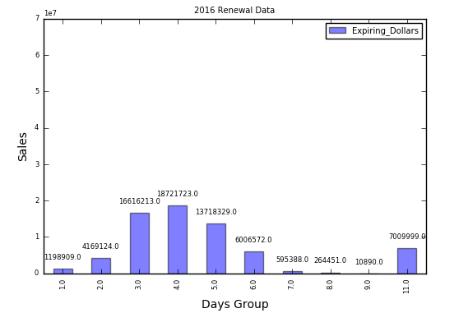

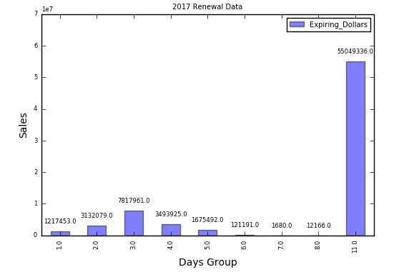

Not Renewed Data Has Increased which was Expected.

Change in the pattern of the Subscription in 2016 Maximum subscription has been done “approx. 30 days” **before** the subscription gets over whereas in 2017 maximum subscription are done prior to “90 days” **before** subscription gets over.

Due to which the 1st four-month Renewals happened in last months of 2016, i.e. Nov Dec due to which we see some of 2017 renewals in 2016. If the pattern follows so we can expect 2018 subscription in 2017 end months.

i.e. If Subscription getting over in Jan2017 due to the pattern it gets renewed in 2016Nov so the sales will account in 2016 data.

#### **Demographic Area Change in 2017**

As the Demographic area plays an important role in research to analyze the impact of demographic factors on consumer choice along with the increasing sales in areas having significant drop in sales.

Analyzing the School count in the Demographic locations.

**Metro Code**

R: Rural Areas U: Urban

S: Sub-Urban T: Town

ZZ: Unknown Area

*Renewed School Counts:*

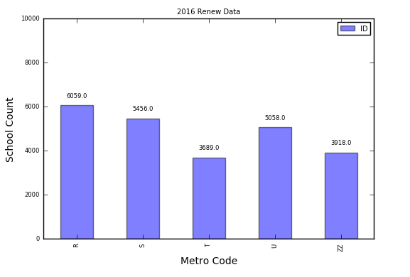

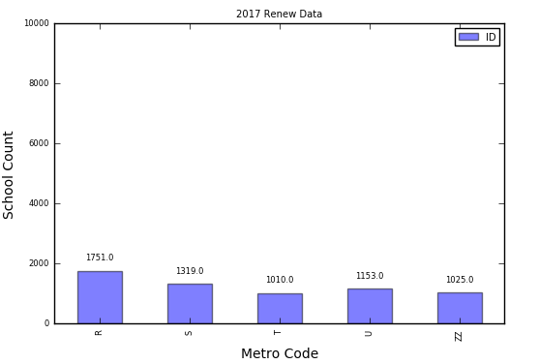

*NON-Renewed School Counts:*

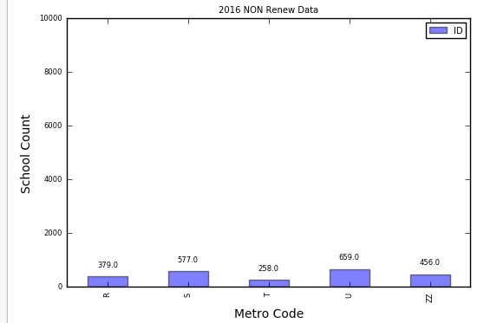

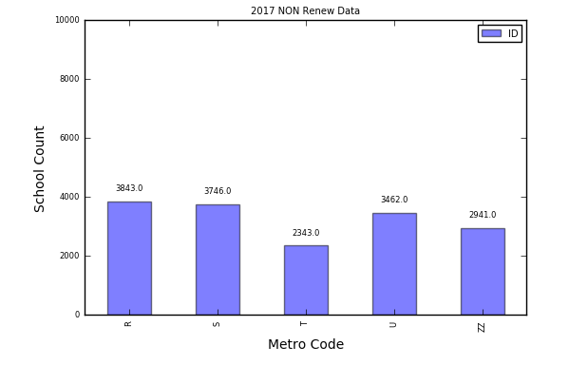

There is Significant amount of Change in the Metro Code

**Renewed Data Change 2016 compared to 2017**

Rural (2016-2017): 72% Drop

Suburban (2016-2017): 75% Drop

Town (2016-2017): 72% Drop

Urban (2016-2017): 77% Drop

ZZ (Unknown Space) (2016-2017): 74% Drop

**NON-Renewed Data Change 2016 compared to 2017**

Rural (2016-2017): 1013% Increase

Suburban (2016-2017): 649% Increase

Town (2016-2017): 908% Increase

Urban (2016-2017): 525% Increase

ZZ (Unknown Space) (2016-2017): 644% Increase

Values are Approx. Values

#### **Average Household Income Change in 2017**

Analyzing the Changes in Average House hold Income in 2017 compared to 2016.

|  |  |
| --- | --- |
| A 1-27,999 | J 48,000-51,999 |
| B 28,000-31,999 | K 52,000-54,999 |
| C 32,000-34,999 | L 55,000-59,999 |
| D 35,000-36,999 | M 60,000-64,999 |
| E 37,000-38,999 | N 65,000-69,999 |
| F 39,000-40,999 | O 70,000-80,999 |
| G 41,000-42,999 | P 81,000-93,999 |
| H 43,000-44,999 | Q 94,000 Plus |
| I 45,000-47,999 | Z unclassified |

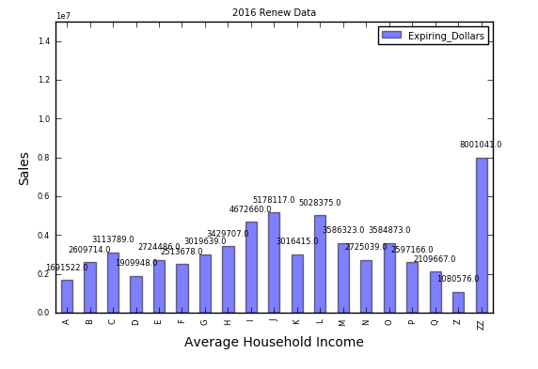

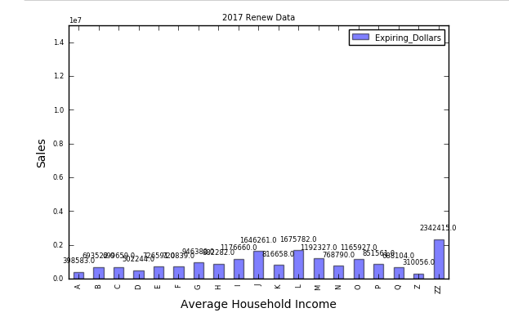

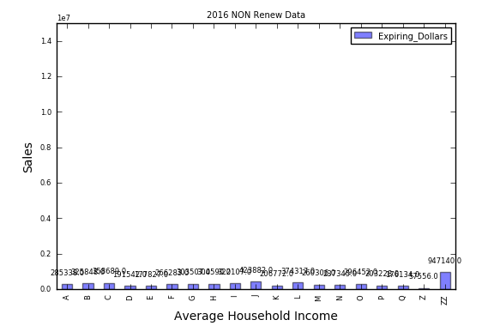

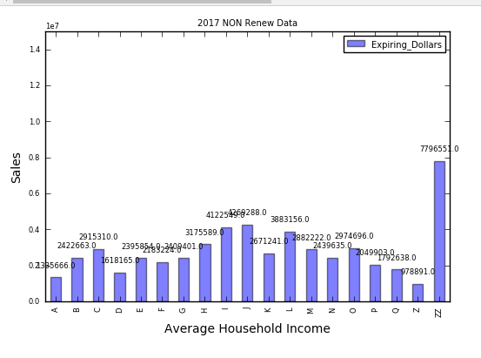

Based on the Analysis there is Slight Decrease in the Average House hold Income for the A

Category A = 1-27,999 compared 2016 to 2017

So, concluding that the Average Income has been Increased and the cost per capita of the house has increased.

#### **Active Students in States**

Active Students are the Students Currently Studying and which grades generally students are all in so that we can predict the number of students that were passing High Schools and Students which are upgrading to next Class.

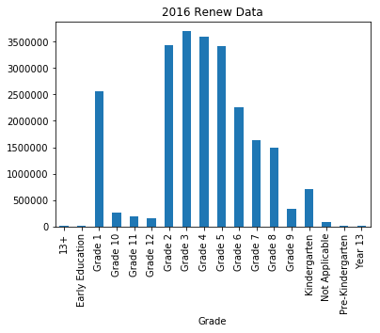

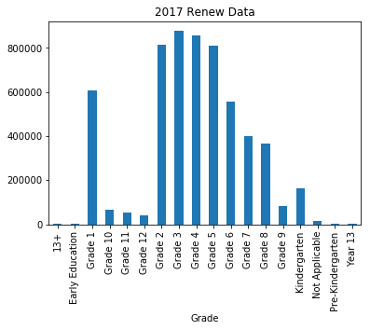

In Both 2016 and 2017 Active Students have majority in Grade 2-6 whereas very less Students are in year 13 or 13+ or in Kinder gardens.

#### **Projecting the Sales for year 2017**

For Successful Projection of the Sales there are various factors which determines the sales like how enriched the data is, how variables are related to each other. How is the correlation amongst the variable are there any dependencies in the variables etc. These factors play important role while predicting the sales.

Checking the Co-relation amongst the variables, As the Correlation amongst the independent variables i.e. Data which we are not predicting must be low so the prediction can be better.

We can predict the Number of School which are having the chances of getting renewed and after we get the number of schools we can multiply the Students with the Current Increased rate of 2017 which is 8$ so that we can get the final projected revenue generated.

Checking the Correlations amongst the variables light color represents low correlation whereas dark represents more correlation, for ideal prediction we need less correlation i.e. Light Color graph.

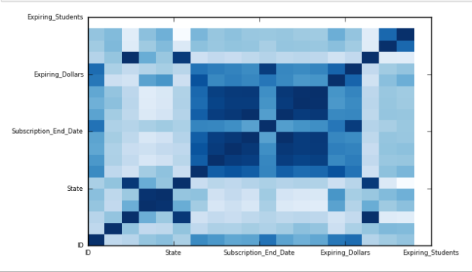

As the correlation graph is light in Color. But we can see some dark areas in the centre as for the better prediction we need to remove the collinearity from the independent variable then only we can predict the sale prices with better accuracy and with better precisions.

After Checking the Correlation matrix dropped certain high correlated values. After dropping the values, we can see the new correlation plot as: -

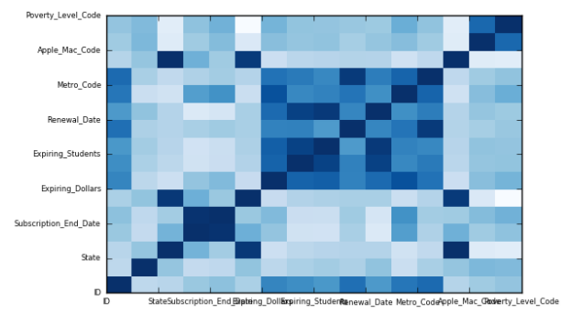

As we are Classifying the Sales by first checking whether the School will renew the Sales or not, after successful classification we can project the Sales based on Student count. Currently we have huge number of unsubscribed customer in 2017 Data, how many of those Non-Renewed customers will further Renew the Subscription?

We have used the predictive modelling based on the given data which consist of sales and demographic information.

Used Logistic regression based and with tuned parameters we have successfully predicted the customer or Schools having the chances of renewing the subscription.

Model accuracy is around 94% percent.

In 2017, we have 16335 School we have who has not Renewed the Subscription.

Projected Renew Chances of the Schools: -

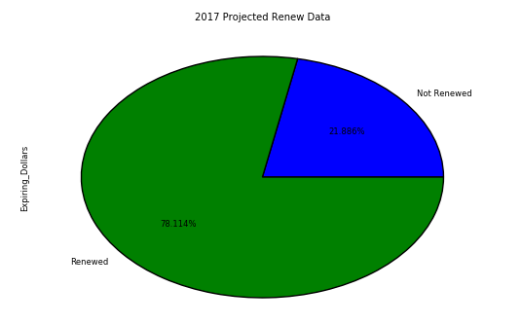

Approx. 78% of the Schools will renew the Subscription.

Which is equal to 12,742 schools, projected that 12,742 Schools will renew the Subscription. In 12,742 Schools, there are 6921967 number of Students.

So, The Projected Revenue of 2017 will be 6921967 * $8 = 55375736$ Dollars

Where as in 2016 the projected revenue is = 54591694$ Dollars

Which Projected there will be profit in 2017 Revenue.

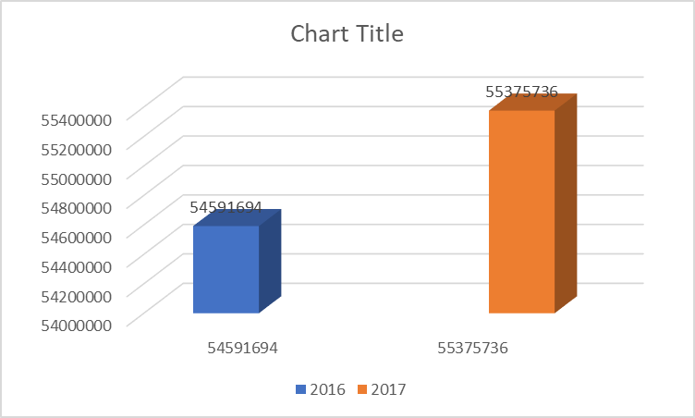

Months in which Most of the Subscriptions are getting Ended: -

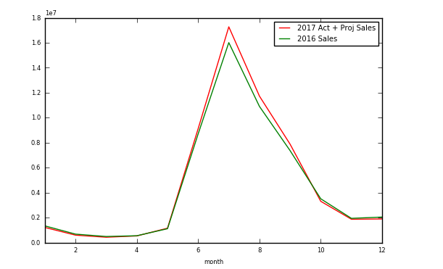

As we can see most of the Subscriptions are getting end in moth of August so by taking in account the Renew pattern

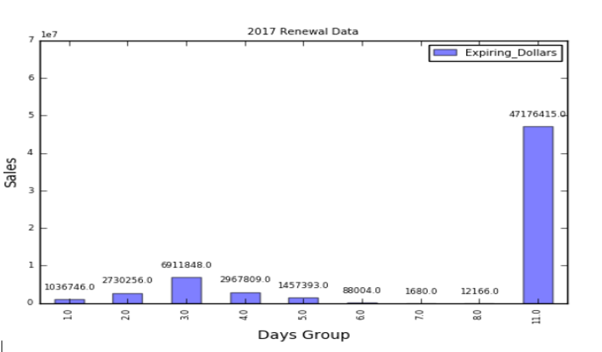

We can expect the Aug months Subscription will be held in May or June as per the Trends seen in 2017 Renew Data.

#### **NON-RENEWED ScHOOLS 2017**

As we have Successfully Projected of the Sales, can we project the Schools which are having the chances of not getting Subscribed?

Yes, we can project the Schools which are having highest chances of not getting subscribed this year.

We have captured the Schools count based on the States in US. Like which State has the highest number of schools not getting subscribed this year.

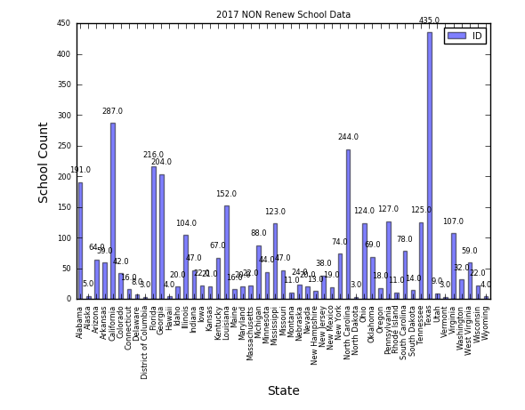

Texas, North Carolina, and California has highest Chances of School Not renewing the Subscription followed by Florida and Georgia.

#### **Sugessted SOlutions**

As we have seen that Texas, North Carolina, and California has highest Chances of School Not renewing the Subscription followed by Florida and Georgia. We can provide the information to the sales team with respective schools. Sales team can provide some discounts or flexi renewal plans to the schools so that the sales can be increased.

Sales team needs to focus on these states and schools which are having more chances of not getting renewed.

Sales Team can apply following measures as to increase sales

1. Create and maintain favorable attention on Schools who are having high chances of not renewing the Subscription.
2. Sell to customer needs: Despite having all the predictions and having reasons for not renewal of sales we have ask customers of the problem they have like if some customer Budget is the issue suggest the Flexi plans according to their needs.
3. Provide Bundle offerings: Businesses have found success by selling bundled products and services as a package rather than individual offerings.

#### **Problem Statements ANSWers**

Sales are down in the US for the first four months of 2017 compared to the first four months of 2016. Why?

* Sales are down in US for 1st four months of 2016 compared to 1st four months of 2017 are the change in the pattern of renewal rates and Cost of the product has increased.

Are there any demographic factors that could account for the decline in sales?

* Yes, there are demographic factors that are affecting the sales.

Have there been any changes to the Key Performance Indicators that would account for this drop? (Ex: Renewal Rates, Average Selling Prices, etc.)

* Yes, there has been a change in Average Selling Prices due to which sales got dropped.

Are we experiencing a lag in the timing of subscription renewals?

* Yes, we are experiencing time lag in the timing of subscription renewals.

Are there other factors that could be influencing the year-over-year decline?

* Yes, there are other factors as well affecting the sales.

Based on these results, project total renewed dollars for all subscriptions expiring in 2017.

* The total sales projected for year 2017 will be around 58813464$ Dollars

What recommendations do you have to improve subscription renewals for the rest of the year?

* We can improve the renewals subscription by targeting the customers which are having high chances of not renewal, we can focus on the customers and if the customers renew the subscriptions we can add extra amount in the sales.

From the given set of data, what are the key factors influencing renewals?

* Average Selling Prices, Demographic location, Active Students are the Key factors on influencing renewals.

What would be the expected renewal rate for 2017?

* Expected Renewal rate will be around 90%

Renewal rate = 2017 Renewed / 2017 Total Sales (Renewed + Non-Renewed)

Renewal rate = 12742 / 19910 = 0.64 (approx.)

Is it possible to flag the schools that are at high risk of not renewing?

* Yes, it is possible to flag the schools having high risk of not renewing.

Are there levers that the sales and customer service teams can pull, to positively influence renewal rates?

* Yes, we can provide information to sales and customer service teams to positively influence renewal rates.

#### **Quality Check**

After the Successful Prediction of the 2017 School Renewal Data we need to check about the integrity of the Data after the prediction, this insures that there is no loss of Data during the analysis, transition, and modification of Data. If Data loss is there the results were not accurate and can misled the information and Stats.

Quality Check accomplished by the Counts of the Schools in 2017 before and after the analysis if the count generation is same we can say that there is no loss of data during the transition.

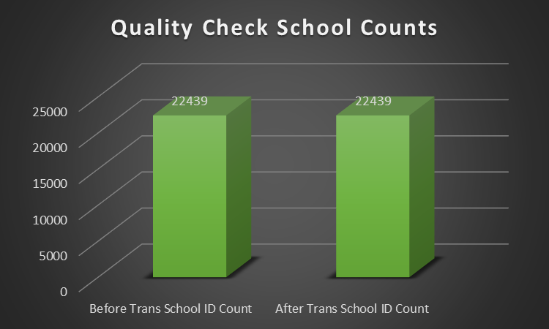

As we can see we have maintained the Integrity of Data During the Transition and Prediction of the Sales.